Getting Started with The Careers College™
FREE ANNUAL SUBSCRIPTION FOR OACEP ATTENDEES

Overview:
The Careers College™ is a program that provides you with a systematic guide to landing a great job. In today’s competitive labor market, just sending résumés to websites advertising open jobs likely won’t cut it. In fact, upwards to eight out of every ten new jobs are never advertised. For those jobs that are advertised, your odds of getting an interview are often less than one in 100. However, there is an effective method to getting a great job, and The Careers College™ will show you how. The Careers College™ consists of nine (9) learning modules, each sharing insider secrets to mastering a critical step in the job search process. Whether you take all nine (9) modules, or just explore a single topic, The Careers College™ is here to help you succeed.

To Get Started with The Careers College™:
- Go to www.tcclearning.com.
- Click on Login/Register.
- Select the SEMESTER OR 1-YEAR program and complete the Student/Staff Subscription Form.
- Enter in Activation Code OACEP100. Please use all CAPS for Activation Code.
- Click on the Accept Terms and “Process Subscription” buttons and Enjoy the program.
- You should also receive two system emails. One with user account details. The other that is a subscription confirmation. If it does not arrive, check your Spam folder. If it is not in your spam folder, email info@thecareerscollege.com.
- To begin, simply click on the Welcome Center or a Learning Module link. Enjoy!

Each Learning Module Contains:
- 10 to 15-minute instructional overview video.
- E-Textbook with an introduction, three (3) sections and a summary, worksheets, tools and resources.
- Each section has a “cliffs notes” page providing an overview of each topic.

To Get the Most out of The Careers College™:
- Take the Job Search Assessment found in both the Welcome Center and Tools sections to determine where you should invest the most time.
- At a minimum, watch each instructional video to learn what to do for each step of the job search process. To watch the video, simply click on the Play Button.
- For those areas of the process where you would like the most help, read the e-text and complete the exercises as you go to apply what you learned to master that step of the job search process.
- Want help on a topic? No problem. Simply type in the topic in the search bar.
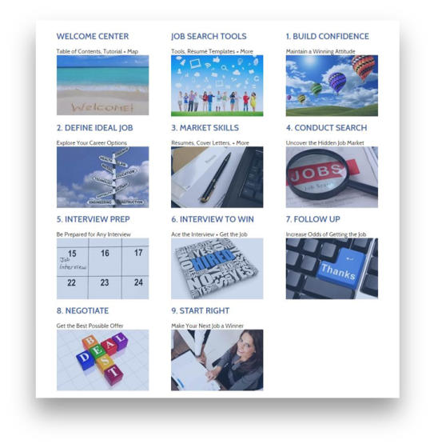
- Whether you spend 10 minutes or several hours using The Careers College™, they key to landing a great job is to use it. Login today.

